Go to http://janetbelch.com

Click on the Accounting Tutorial Link. Your screen should look the one below.

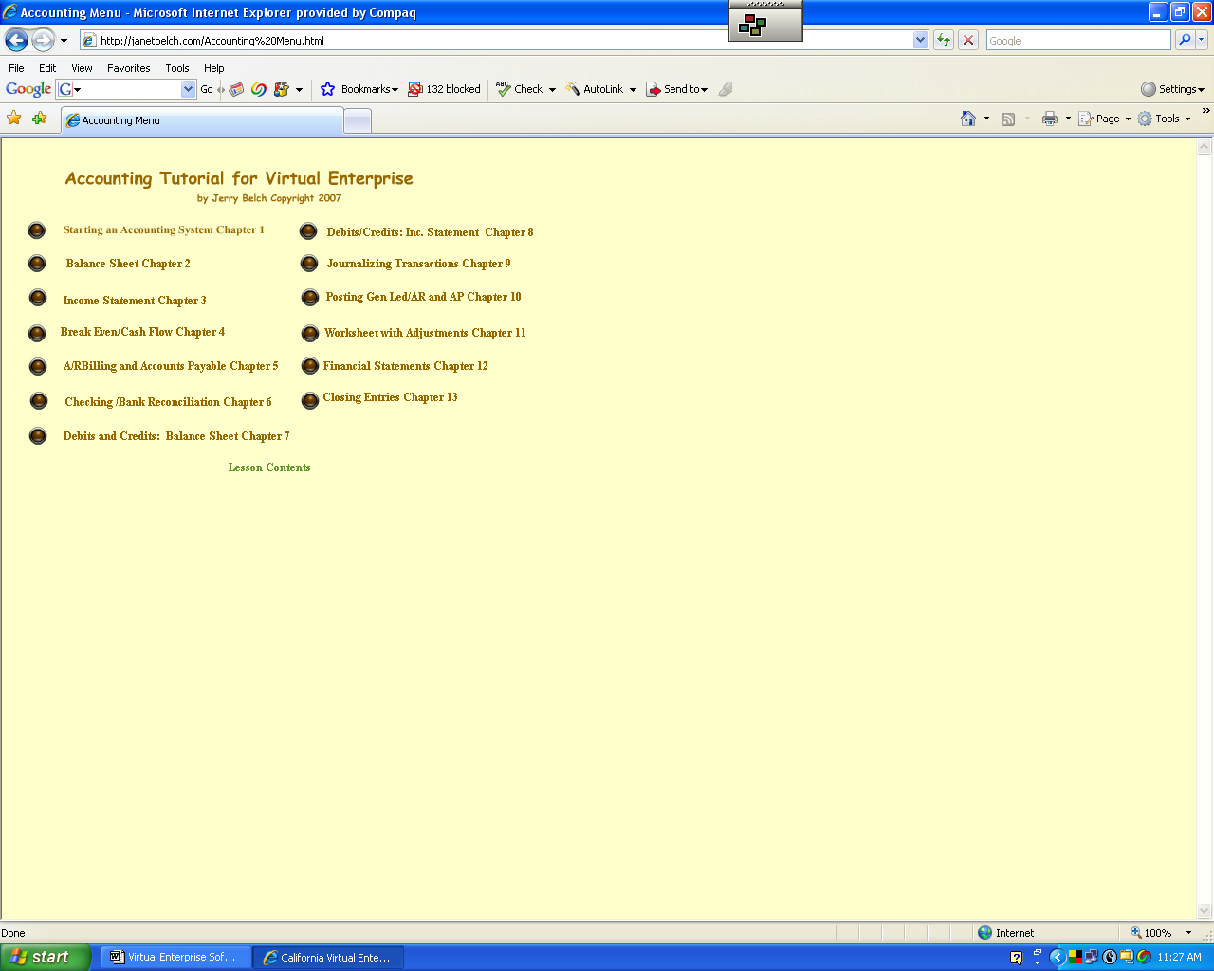

Select the Income Statement Lesson. Your screen should look like the one below.
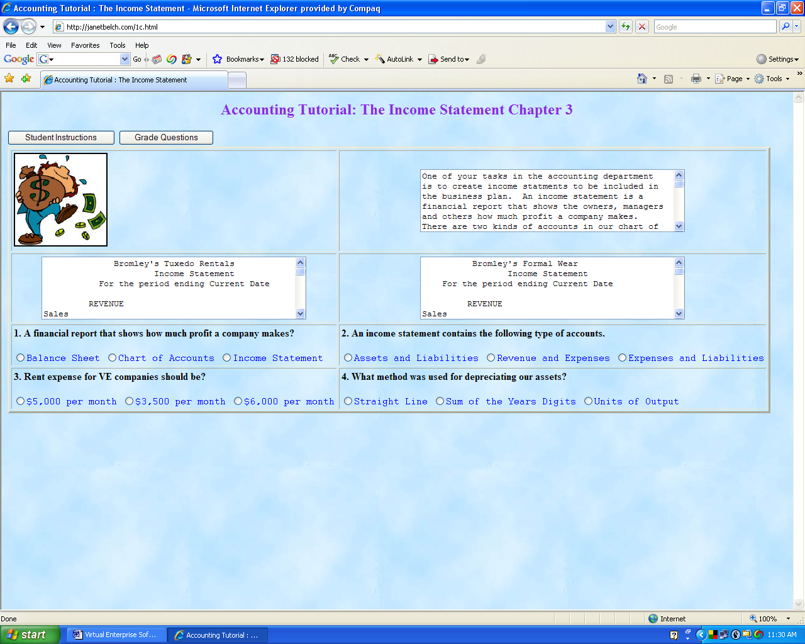

Teachers’/Students’ Worksheet for the Accounting Training
Income Statement Lessons
1. _____ Income statements are included in the Business Plan for Virtual Enterprise. (T/F)
2. _____ A balance sheet shows how much profit a company makes. (T/F)
- What two types of accounts go on the income statement? __________
_______________
4. List five expenses common to all companies. __________ ________
___________ _____________ ____________
5. _____ Normally an income statement is generated from the general ledger. (T/F)
6. What are two kinds of income statements? _____________ __________
- How can your find your standard payment rates for companies? ______________
- _____ Some of the expenses for your company are based on the number of students in your class. (T/F)
- If you have 30 students in a class, what is the amount of the electric bill? _____
- _____ The portion of the loan that is interest belongs on the income statement. (T/F)
- Take the on-line test. What was your score? ________
Press the right arrow key on your keyboard to see the second half of the income statement lesson.
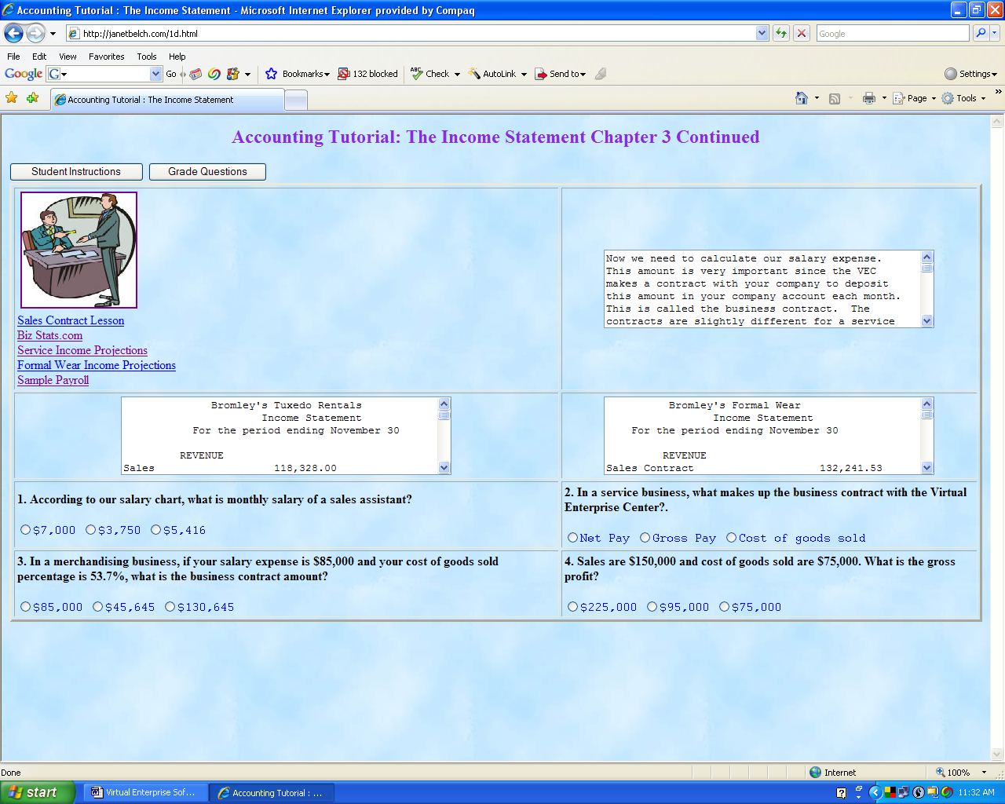
- Why is important to calculate salary expense as soon as possible? ____________
___________________________
- What is the amount of salary expense called by the Virtual Enterprise Center? ____________
- _____ The business contract is calculated on net pay. (T/F)
- For a company that has merchandise for sale, what important element is added to salary expense for the business contract? ____________
Click on the picture in the accounting tutorial on this page to see some salary ranges for your employees.
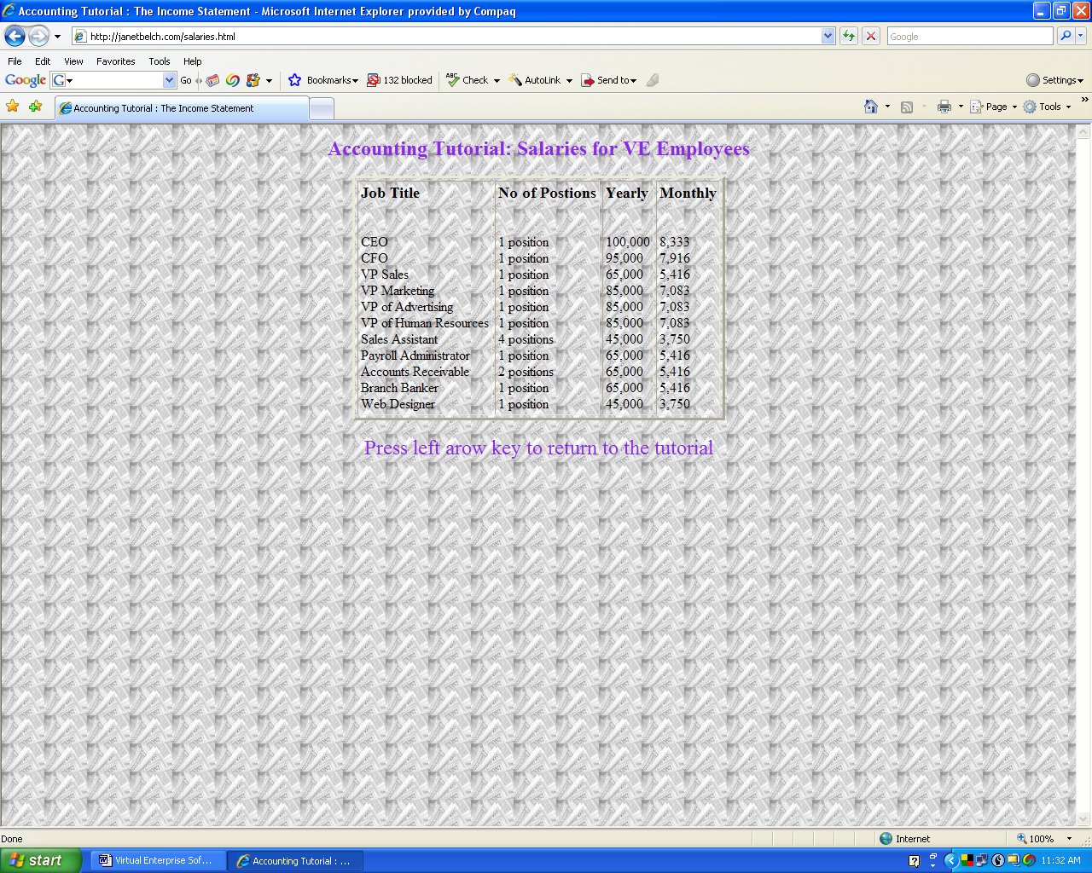
- What does the CEO get per year? ______ per month?______
Press the left arrow on your keyboard to return to the main body of the tutorial.
Click on the sample payroll link.
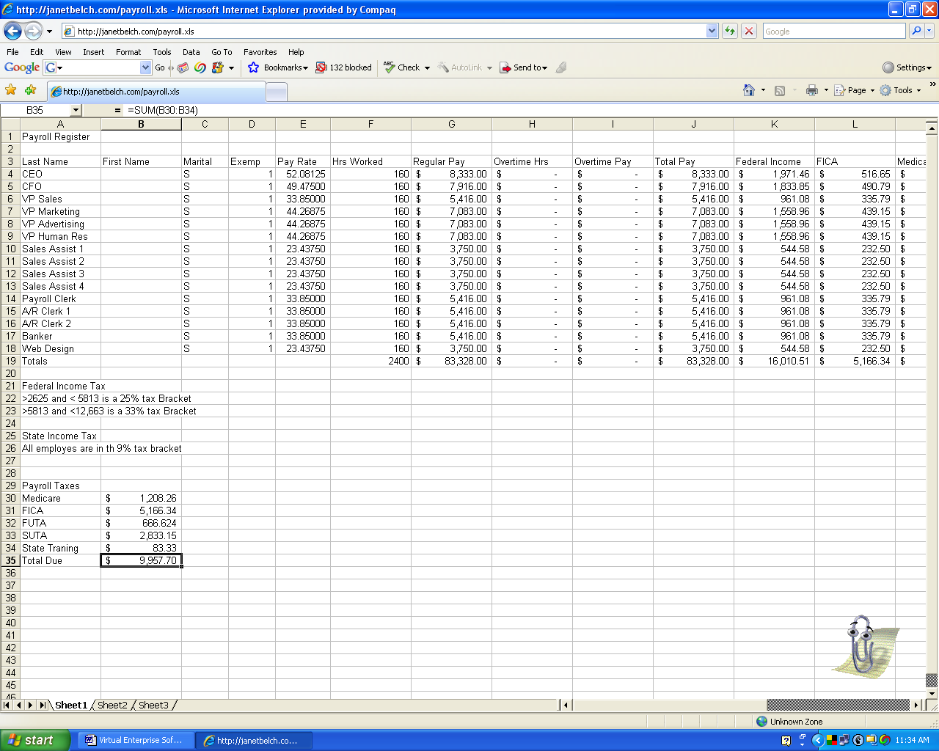
Here is where you can calculate your salary expense. You will notice that when it is loaded, you can see it is a Microsoft Excel Spreadsheet. Everything is calculated for you: gross pay, deductions, all columns are totaled and payroll taxes are calculated. You can substitute your students their hours and pay rates. All the rest will be done for you.
- What is the total gross amount of the payroll? ______. This is your business contract amount for a service-oriented business based on these hourly rates and hours worked.
Click on the Biz-stats link.
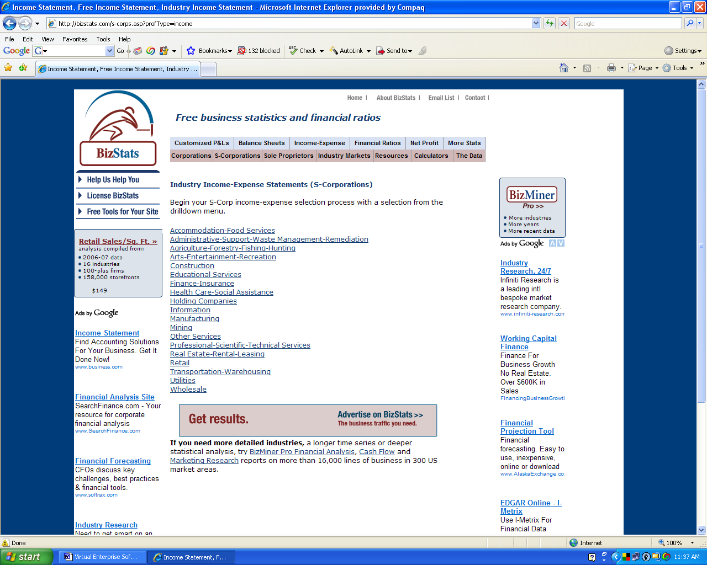
Select Retail.
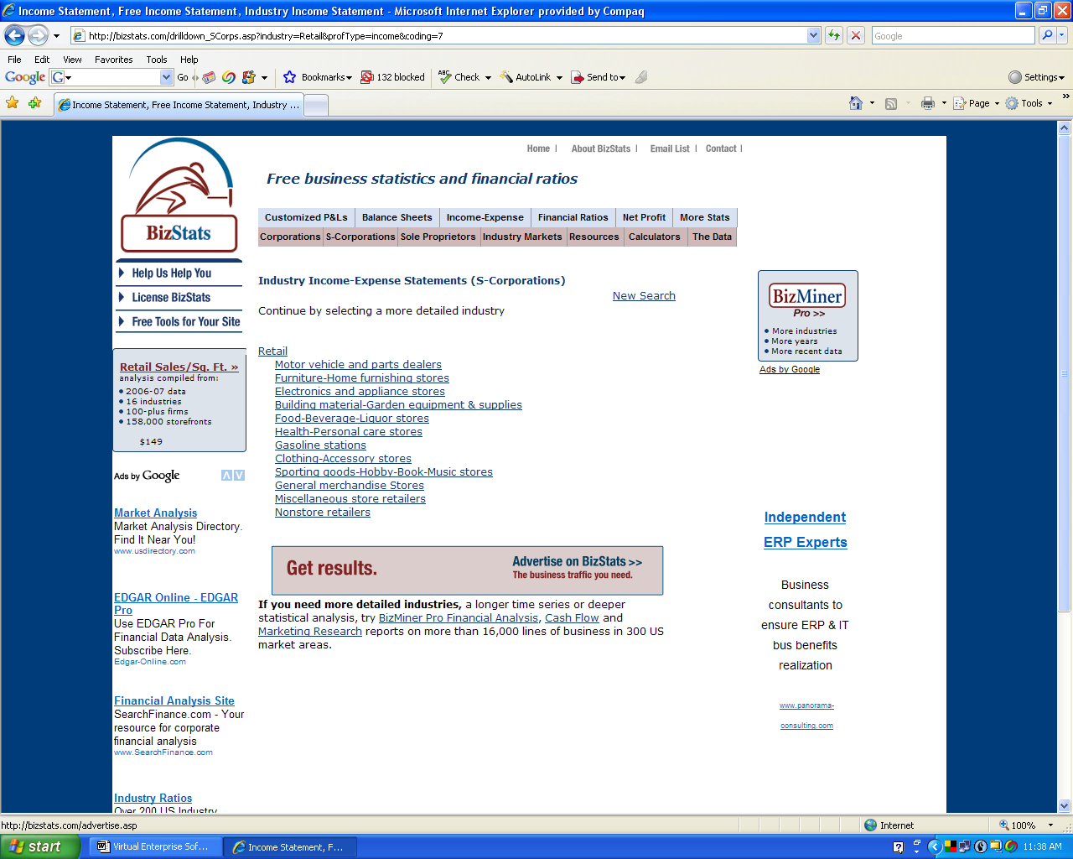
Select Electronics and Appliance Stores.

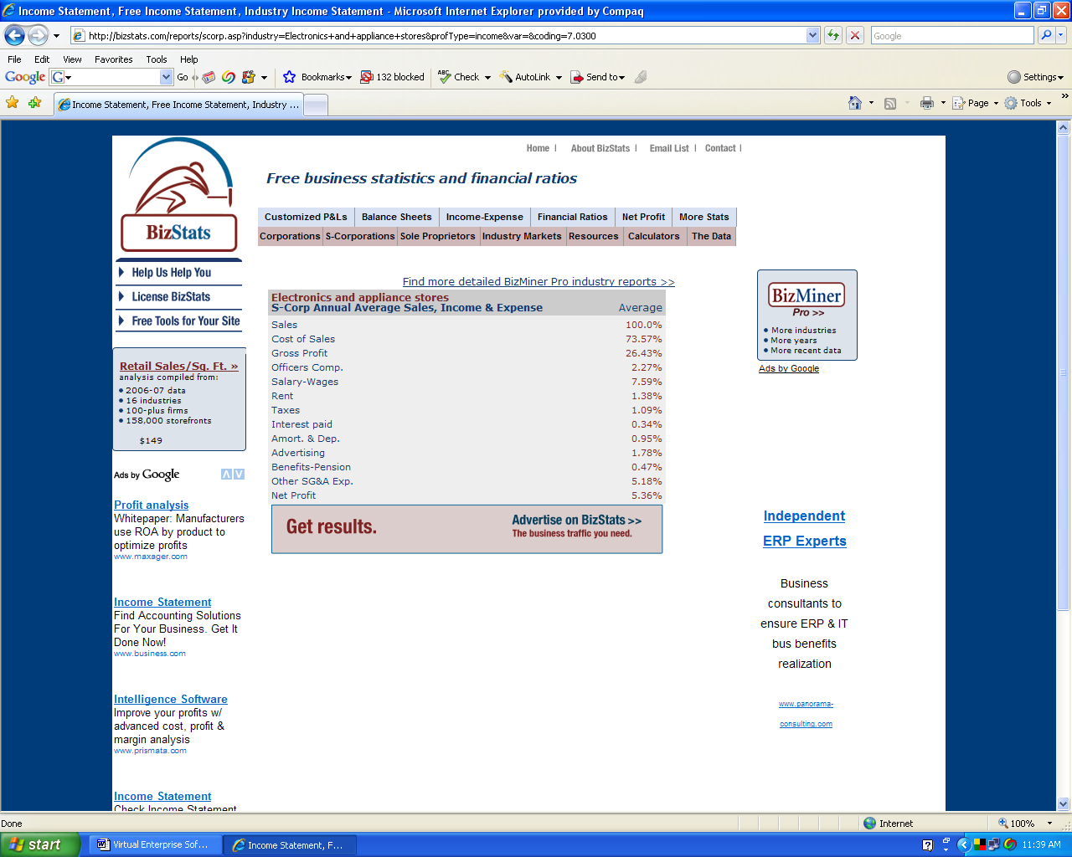
- What is the cost of sales percentage for this type of business? ______
Click the Back button on the browser to return to the tutorial.
- Answer the on-line questions. Did you miss any? ______
Return to janetbelch.com, home page by using the back buttons or retyping the URL.
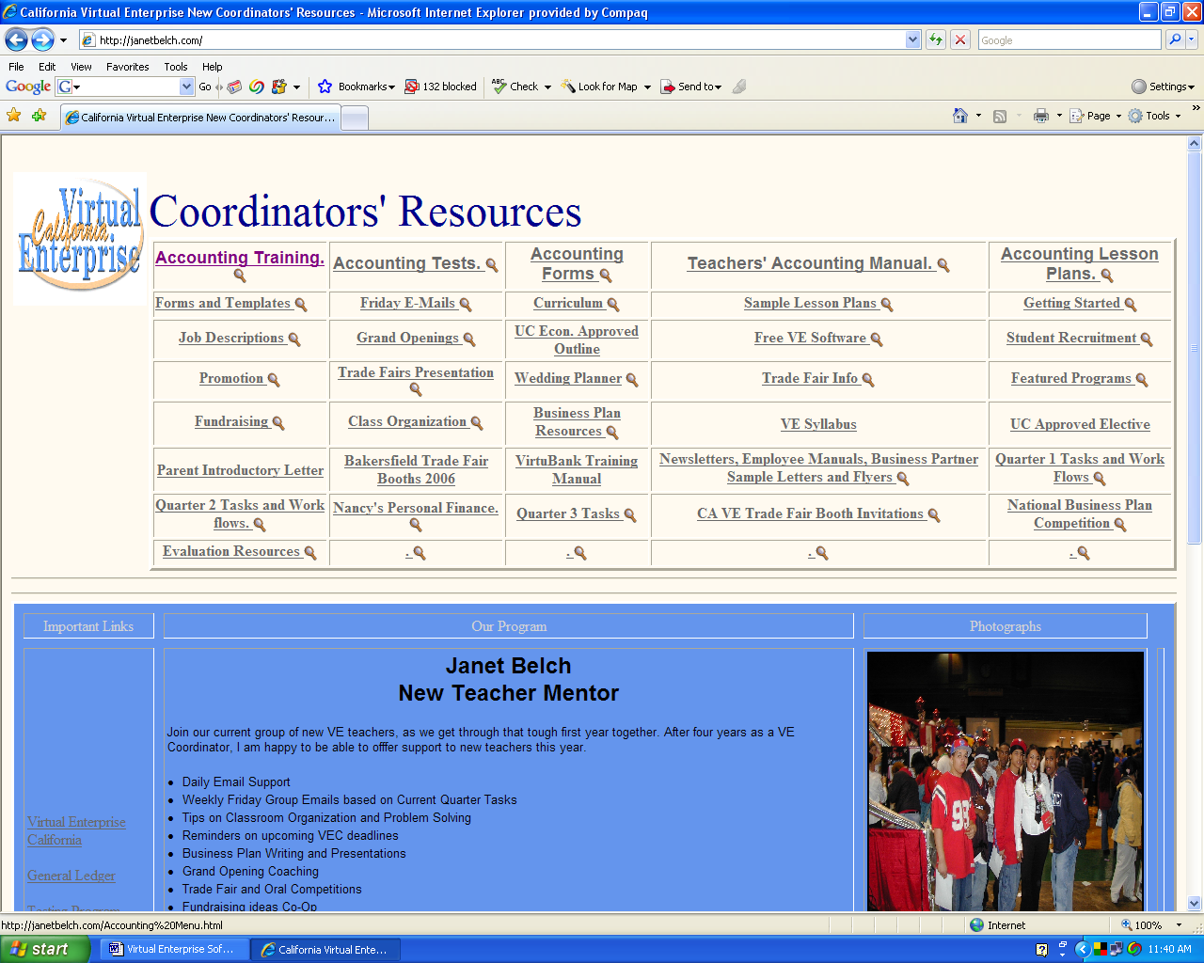
Now it is time to take a test on the material covered in the income statement lessons. Click on Accounting Tests.
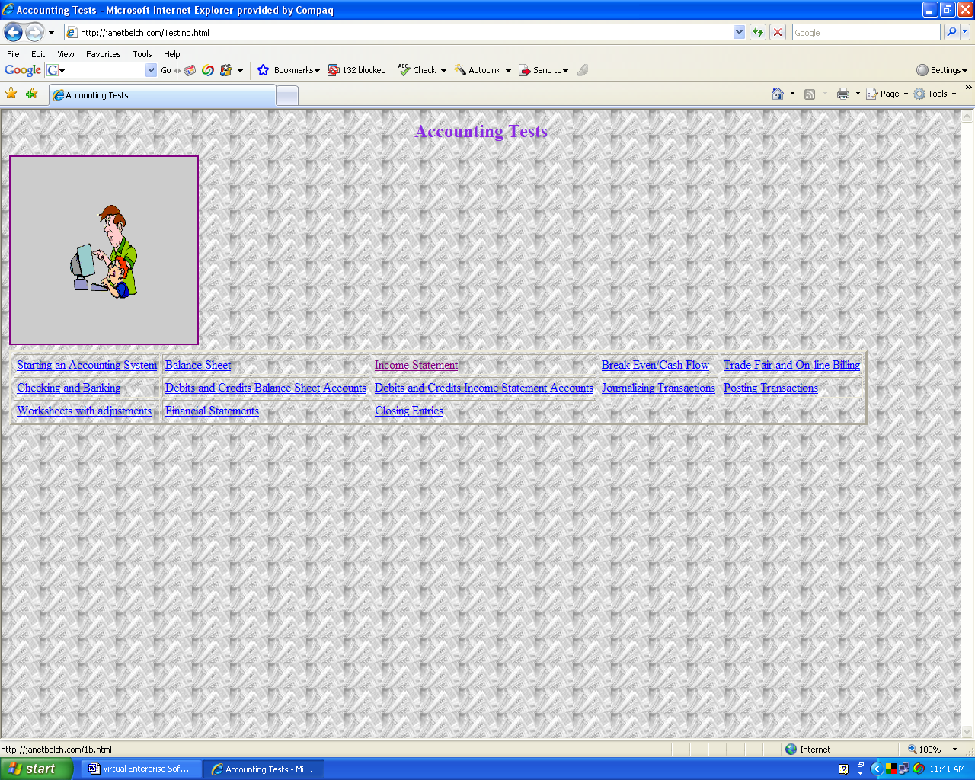

Select Income Statement.
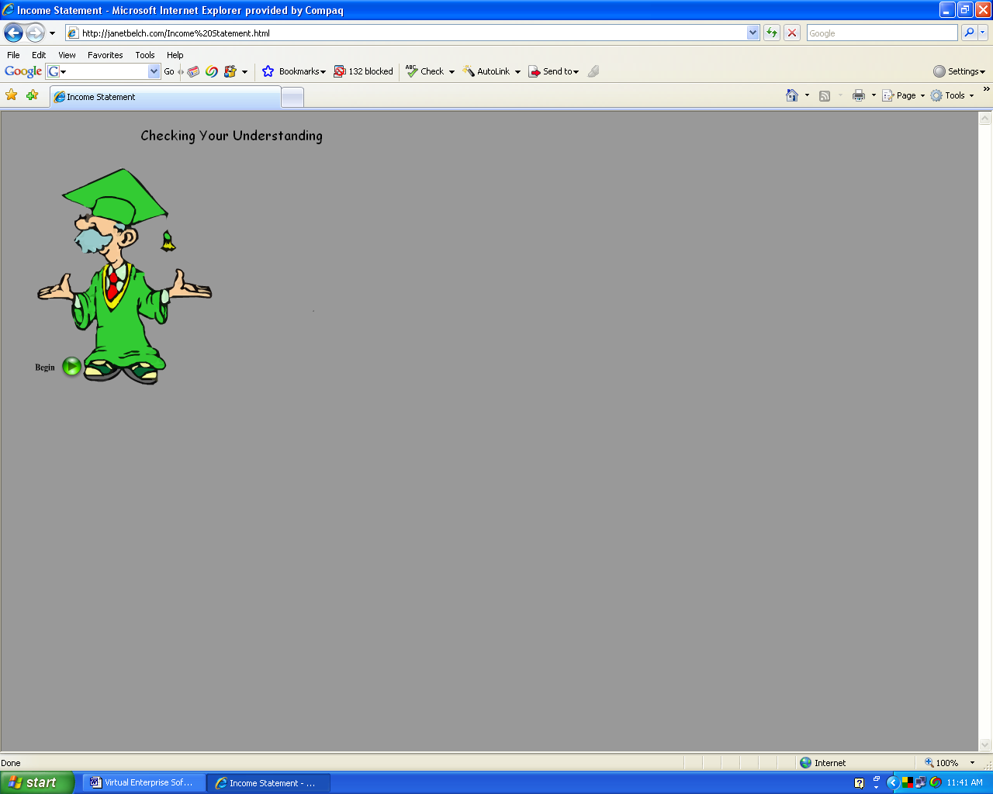
Click Begin.
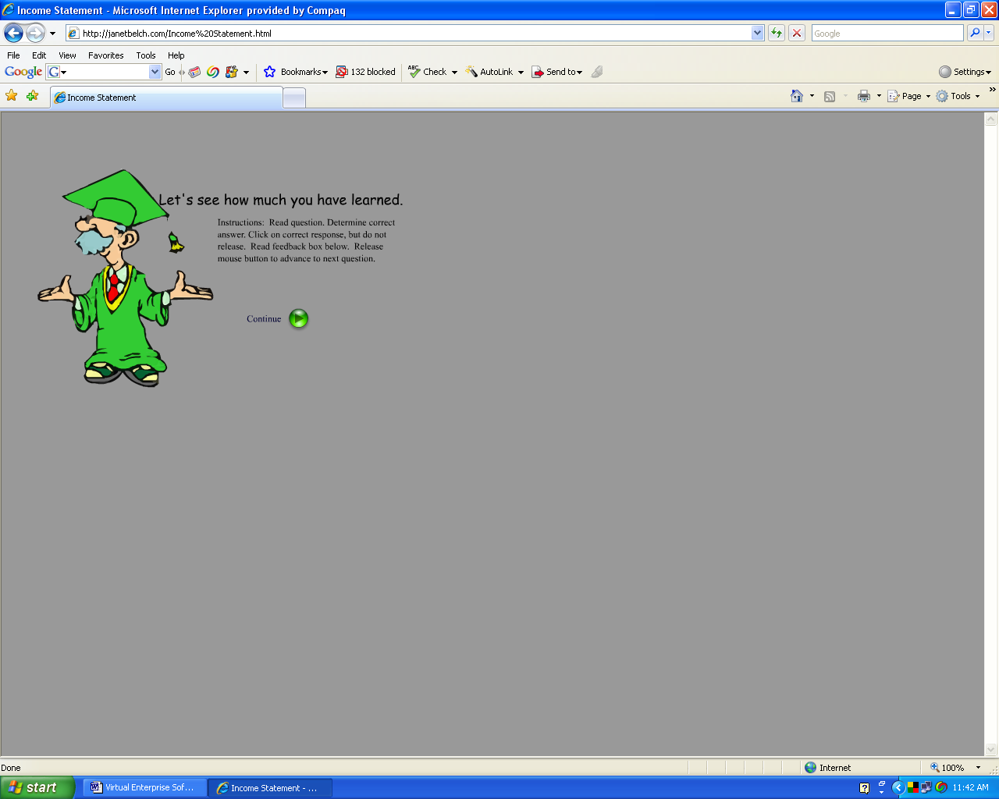

Read student instructions. Click Continue.
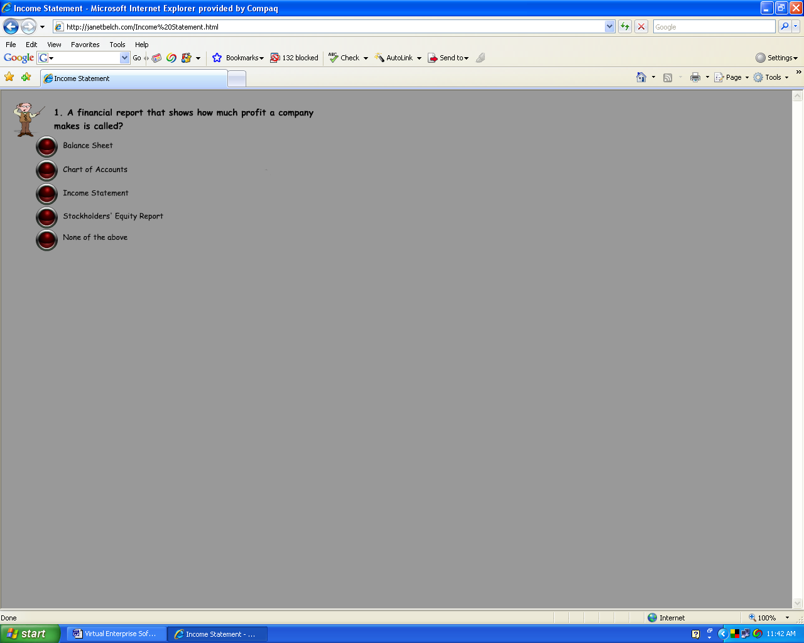

Answer the questions.
- What was your score? _______
Return to janetbelch.com home page by using the back buttons on the browser of retyping the URL.

